Membership

- Individual Friend (UK) £25 per year

- Joint Friends (two people at one address): £35 per year

- Individual Friends Overseas: £25 per year

- Joint Friends Overseas (two people at one address): £35 per year

Your details

Title: ……………. Name: ………………………………………… DOB: …../…../…..

Title: ……………. Name: ………………………………………… DOB: …../…../…..

(joint membership only)

Address: ………………………………………………………………………………………

………………………………………………………………………………………………….

………………………………………………………………. Postcode: ……………………

Primary email address: ………………………………………..........................................

Secondary email address: …………………………………………………………………..

Please note: Joint membership will receive newsletters to two email addresses if required.

I wish to support Cynon Valley Museum by purchasing a lottery ticket. Please contact us on 01685 886729, or fundraising@cynonvalleymuseum.wales to arrange this separately.

Payment details

 Cheque made payable to Cynon Valley Museum Trust

 Cash/Card (in person)

Gift Aid

You can increase the value of your membership fee by completing a Gift Aid declaration. If you are a UK taxpayer, please tick the box below to join the Gift Aid scheme. Doing so will mean that we can claim up to 25p extra for every £1 you give us, at no additional cost to you.

Yes, I am a UK Taxpayer. Please treat all donations I make or have made to Cynon Valley Museum Trust for the past 4 years as Gift Aid donations until further notice. Your data shall be retained in line with current GDPR legislation.

I am a UK taxpayer and understand that if I pay less income Tax and/or Capital Gains Tax than the amount of Gift Aid claimed on all my donations to charities and Community Amateurs Sports Clubs (CASCs)in that tax year, it is my responsibility to pay any difference. Cynon Valley Museum Trust will claim 25p for every £1 donated.

Name (please print) Date:

Please let us know if you want to cancel the declaration, change your name and/or address, or no longer pay sufficient tax on your income and/or capital gains.

Thank you for supporting the work of Cynon Valley Museum Trust

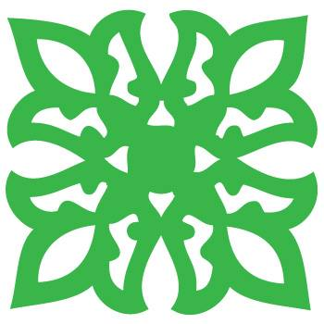
Please return to:
Fundraising Co-ordinator, Cynon Valley Museum, Depot Road, Aberdare, CF44 8DL
or by email fundraising@cynonvalleymuseum.wales

The Cynon Valley Museum Trust is a registered charity. Charity number 1161227

