Membership type (see brochure for guidance)

- Individual Friend: £20 per year

- Joint Friends (two people at one address): £35 per year

- Young Friends (13 and under): £15 per year

- Teen membership (13 to 18 years): £15 per year

- Young Adult (18 -25): £15 per year

- Family (up to 6 people at the same address): £60 per year

- Distant friends UK Individual: £20 per year
Joint (two people at one address): £35 per year

- Distant friends overseas Individual: £25 per year
Joint (two people at one address): £45 per year

Your details

Title: ……………. Name: ………………………………………… DOB: …../…../…..

Title: ……………. Name: ………………………………………… DOB: …../…../…..

(joint membership only)

Title: ……………. Name: ………………………………………… DOB: …../…../…..

Title: ……………. Name: ………………………………………… DOB: …../…../…..

Title: ……………. Name: ………………………………………… DOB: …../…../…..

Title: ……………. Name: ………………………………………… DOB: …../…../…..

(family membership only)

Address: ………………………………………………………………………………………

………………………………………………………………………………………………….

………………………………………………………………. Postcode: ……………………

Principle email address: ………………………………………..........................................

Alternative email address: …………………………………………………………………..

Please note: joint membership will receive newsletters to two email addresses if required.

I wish to support the museum by purchasing a lottery ticket

Payment details

 Cheque, made payable to Cynon Valley Museum Trust

 Cash (or card if in person)

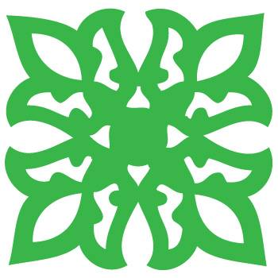
Please return to:
Friends Co-ordinator, Cynon Valley Museum, Depot Road, Aberdare, CF44 8DL
or by email to admin@cynonvalleymuseum.wales

The Cynon Valley Museum Trust is a registered charity, number 1161227

